Criterion D: Applying mathematics in real-life contexts
Level | Level descriptor | Task-specific clarification
0 | You do not reach a standard described by any of the descriptors below. | You did not reach a standard as described by any of the descriptors below.
1-2 | You are able to:  • identify some of the elements of the authentic real-life situation  • apply mathematical strategies to find a solution to the authentic real-life situation, with limited success. | You demonstrated the ability to:  • identify the positions of at least eight places and any other relevant element in the given problem  • select adequate strategies needed to model the distance between the school and places.  • apply mathematical strategies to obtain to obtain a correct solution and a set of logical conclusions about the process. Questions A to H attempted
3-4 | You are able to:  • identify the relevant elements of the authentic real-life situation  • select, with some success, adequate mathematical strategies to model the authentic real-life situation  • apply mathematical strategies to reach a solution to the authentic real-life situation  • discuss whether the solution makes sense in the context of the authentic real-life situation. | You demonstrated the ability to:  • identify the positions of at least eight places and any other relevant element in the given problem  • select adequate strategies needed to model the distance between the school and places.  • apply your selected strategies to obtain a correct solution and a set of logical conclusions about the process. Questions A to H answered with few mistakes
5-6 | You are able to:  • identify the relevant elements of the authentic real-life situation  • select adequate mathematical strategies to model the authentic real-life situation  • apply the selected mathematical strategies to reach a valid solution to the authentic real-life situation  • explain the degree of accuracy of the solution  • explain whether the solution makes sense in the context of the authentic real-life situation. | You demonstrated the ability to:  • identify the positions of at least eight places and any other relevant element in the given problem  • select adequate strategies needed to model the distance between the school and places.  • apply your selected strategies to obtain a correct solution and a set of logical conclusions about the process. Questions A to H with few mistakes  • explain the degree of accuracy of your solution  • explain whether your solution makes sense in the context of a real-life situation. Q. I and J attempted
7-8 | You are able to:  • identify the relevant elements of the authentic real-life situation  • select appropriate mathematical strategies to model the authentic real-life situation  • apply the selected mathematical strategies to reach a correct solution to the authentic real-life situation  • justify the degree of accuracy of the solution  • justify whether the solution makes sense in the context of the authentic real-life situation. | You demonstrated the ability to:  • identify the positions of at least eight places and any other relevant element in the given problem  • select adequate strategies needed to model the distance between the school and places.  • apply your selected strategies to obtain a correct solution and a set of logical conclusions about the process  • justify the degree of accuracy of your solution  • justify whether your solution makes sense in the context of a real-life situation. All points A to J correctly and logically answered.

Criterion C: Communication - Rubric
Level | Your work to achieve this level
0 | There is not enough work to make an assessment.
1 – 2 | You are able to use limited mathematical language and limited forms of graphing data in a 2-D coordinate systems and a number line. You are able to communicate how to analyze or manipulate data through lines of reasoning that are difficult to follow.
3 – 4 | You are able to use some appropriate mathematical language, and different forms of graphing data in a 2-D coordinate systems and a number line. You are able to explain how to analyze or manipulate data through lines of reasoning that can be understood, although there are not always clear.
5 – 6 | You are able to use correctly mathematical language, and different forms of graphing data in a 2-D coordinate systems and a number line. You are able to explain how to analyze or manipulate data through lines of reasoning that can be understood, although there are not always clear. You are able to move between algebraic and graphic representation of data with minor mistakes.
7 – 8 | You are able to consistently use appropriate mathematical language, and different forms of mathematical representation to consistently present information correctly, move effectively between different forms of mathematical representation, and communicate through lines of reasoning that are complete and coherent.

The Problem
Tim, Maria and you, drew a map of your neighborhood for the neighbor association. Unfortunately, Tim’s computer crashed and most of the work have been lost before it was uploaded. Now, you and your team have 1 hour to organize the information and complete the map using some loose notes.

Now, you just remember something…
You have the first draft of the map in your computer! Also, we have some notes in our pockets. Here are most the loose pieces of information.
The hospital has y-coordinate 0. It’s directly south of Tim’s

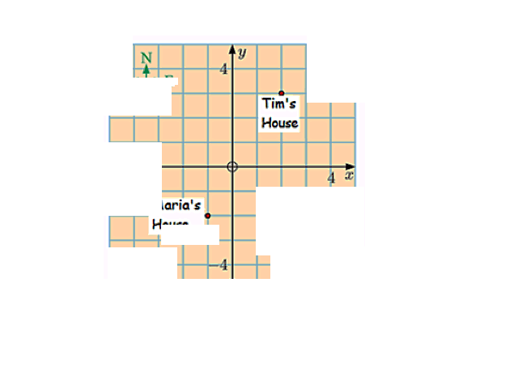

My home is 5 km south of Tim’s.

There is a flower shop in (-0.5, 0.5)
There is a playground in the IV quadrant.

The police station has x-coordinate -3 and it’s 3 km north of Maria’s.
There is a park located directly north of Maria’s house, and directly
southwest of Tim’s house.

We got to the library by walking straight west from Tim’s or straight north from the school.

Maria’s home is 2 km south of the school.

Tostino’s Restaurant is in front of the park.

Here is the work you have to do for the neighborhood association.

- Create a map of your neighborhood with at least eight places.
- The eight places include the homes of all members of the group.
- Use a coordinate system to show your data.
- Place the school at the origin.
- Calculate the distance you need to travel in a car from the school to the rest of the places.
- For all locations in your map, display the name, coordinates and the distance to the school.
- Show the orientation of the map.
- Show the scale on the map.
- Explain how accurate are the positions in this map, and how accurate are the distances calculated using the map.
- Discuss whether a map like this is a good tool for the neighbors. Explain your answer.

